# **Pizza sales report**

1: **Total revenue**

select sum(total_price) as total_Ravinue from pizza.pizza_sales;

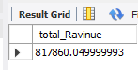

2: **Average Order Values**

**select sum(total_price)/count(distinct order_id ) avg_Order from pizza.pizza_sale**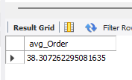

**3: Total Pizza Sold?**

**select sum(quantity) total_pizza_sold from pizza.pizza_sales;**

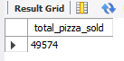

**4: Total Order?**

**select count(distinct order_id) from pizza.pizza_sales;**

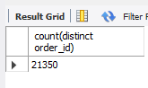

**5: Average pizza per order?**

**select cast(sum(quantity)/ count(distinct order_id) as decimal(10,2)) as avg_per_order from pizza.pizza_sales;**

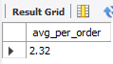

**FOR CHART**

1. **Daily Traind For Total Order?**

**1st check order_date datatype.**

**select * from information_schema.columns**

**where table_name= 'pizza_sales';**

**change text to date format**

**update pizza.pizza_sales**

**set order_date=str_to_date(order_date,"%d-%m-%Y");**

**select dayname(order_date) order_day , count(distinct order_id) Total_order from pizza.pizza_sales**

**group by dayname(order_date);**

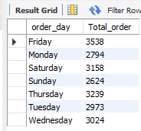

**2- Monthly Trend For Total Order?**

**select monthname(order_date) as month_name, count(distinct order_id) total_order from pizza.pizza_sales**

**group by monthname(order_date)**

**order by total_order desc;**

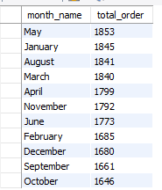

**3: Percentage of sale by Pizza Catagory?**

**select pizza_category,sum(total_price) total_sale_cate, sum(total_price)*100/(select sum(total_price) from pizza.pizza_sales) PSP**

**from pizza.pizza_sales**

**group by pizza_category**

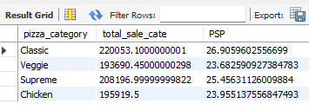

**4: Percentage of sale by Pizza Category in January month?**

**select pizza_category,sum(total_price) total_sale_cate, sum(total_price)*100/(select sum(total_price) from pizza.pizza_sales**

**where month(order_date)=1) PSP**

**from pizza.pizza_sales**

**where month(order_date)=1**

**group by pizza_category;**

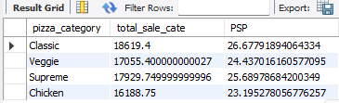

**5: Percentage Of sale of pizza size January month?**

**select pizza_size,cast(sum(total_price) as decimal(10,3)) total_sale_cate, cast(sum(total_price)*100/(select sum(total_price) from pizza.pizza_sales**

**where month(order_date)=1) as decimal(10,3)) PSP**

**from pizza.pizza_sales**

**group by pizza_size;**

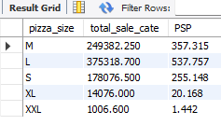

**5: Top 5 best saler by revenue.Total quantity and total order?**

**select pizza_name,cast(sum(total_price) as decimal(10,2)) total_revenue from pizza.pizza_sales**

**group by pizza_name**

**order by total_revenue**

**limit 5;**

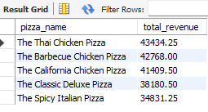

**6: Bottom 5 best saler by revenue.Total quantity and total order?**

**select pizza_name,cast(sum(total_price) as decimal(10,2)) total_revenue from pizza.pizza_sales**

**group by pizza_name**

**order by total_revenue asc**

**limit 5;**

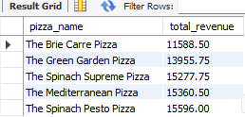

**7: Top 5 Pizza by Quantity**

**select * from pizza.pizza_sales;**

**select pizza_name,sum(quantity) total_quantity from pizza.pizza_sales**

**group by pizza_name**

**order by total_quantity desc**

**limit 5;**

